
RAMAIAH
INSTITUTE OF TECHNOLOGY
USN | 1 | M | S

(Autonomous Institute, Affiliated to VTU)
Bangalore – 560 054

MAKEUP EXAMINATIONS – MARCH 2017

Course & Branch | : | B.E: Computer Science Engineering. | Semester | : | V
Subject | : | Database Systems | Max. Marks | : | 100
Subject Code | : | CS1552/CS513 | Duration | : | 3 Hrs

Instructions to the Candidates:
- Answer one full question from each unit.

 |  |  |  | UNIT- I
1. | a) |  | Identify the role of Database Administrator (DBA) and Database Designers. |  | CO1 |  | (04)
 | b) |  | Discuss any four advantages of DBMS Approach |  | CO1 |  | (08)
 | c) |  | With a neat diagram, explain the following with respect to database system environment.  - User  - Interface  - Storage of data  - Processing of information |  | CO1 |  | (08)
2. | a) |  | How do you define, Structure of a database? Describe different Categories of Data Model. |  | CO1 |  | (06)
 | b) |  | Compare Logical Data Independence with Physical Data Independence |  | CO1 |  | (06)
 | c) |  | Draw ER Diagram for the following Statements with Cardinality and (min,max) notation.  - A man can be married to at most one women and vice versa  - An airport lies in exactly one country. A country may have arbitrarily many airports(and maybe none at all)  - One instructor teaches many courses, but each course is run by exactly one instructor.  - Each department has exactly one department head, some employees are the head of one department. |  | CO2 |  | (08)
 |  |  |  | UNIT- II
3. |  | a) |  | Develop a relational database schema by converting the given ER model.  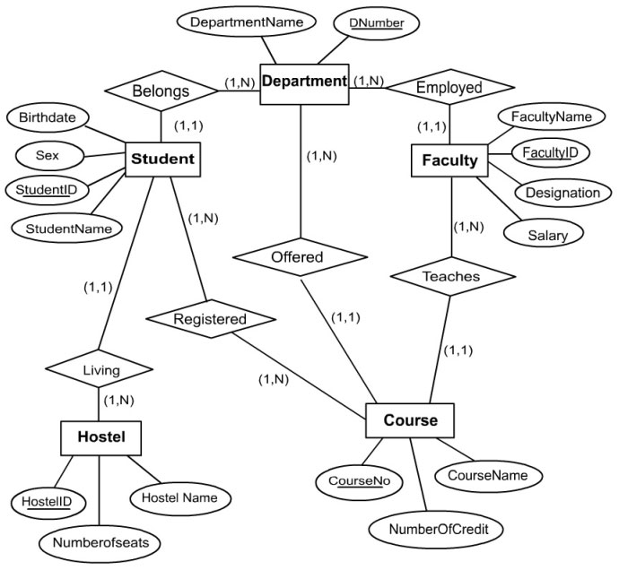 |  | CO2 |  | (10)
 |  | b) |  | Justify the following statements  - Relation must have a key.  - Weak Entities do not have their own key attributes. |  | CO2 |  | (04)
 |  | c) |  | Explain the entity integrity and referential integrity constraints. Discuss why it is important. |  | CO3 |  | (06)
4. |  | a) |  | Appraise about the conditions to be fulfilled for two relations to be involved in a UNION operation. Why do UNION, INTERSECTION and SET DIFFERENCE operations require the operand relations to be union compactable? |  | CO3 |  | (10)
 |  | b) |  | Write Relational algebra expressions for the following  - lives(person-name,street,city)  - works(person-name, company-name,salary)  - located-in(company-name,city)  - manages(person-name,manager-name)  - Find the company with the most employees.  - Delete all tuples in the works relation for employees of Small Bank Corporation.  - Find the names of all employees in this database who do not work for First Bank Corporation.  - Find the names, street address, and cities of residence of all employees who work for First Bank Corporation and earn more than $10,000 per annum.  - Give all employees of First Bank Corporation a 10 percent salary raise. |  | CO3 |  | (10)
 |  |  |  | UNIT- III
5. |  | a) |  | What is a view? How is it useful? Discuss the types of view. |  | CO4 |  | (05)
 |  | b) |  | Define Impedance mismatch. |  | CO4 |  | (03)
 |  | c) |  | Consider the schema given in Question No. 4 (c). Primary keys are underlined.  Write the SQL statements for the following queries:  - For each pilot who is certified for more than three aircraft, find the eid and the maximum cruisingrange of the aircraft for which she or he is certified.  - Find the names of pilots certified for some Boeing aircraft.  - Print the name and salary of every nonpilot whose salary is more than the average salary for pilots.  - Find the names of pilots whose salary is less than the price of the cheapest route from Bengaluru to Mumbai. |  | CO4 |  | (12)
6. |  | a) |  | Write an Embedded SQL code snippet to retrieve Multiple tuples from a database. |  | CO4 |  | (05)
 |  | b) |  | Write an assertion in SQL to specify a constraint such that the salary of an employee must not be greater than the salary of the manager of the department that the employee works for. Explain the same in brief. |  | CO4 |  | (03)
 |  | c) |  | Consider the schema given below for a university database. Primary keys are underlined.  Dept(dept_name, building, budget)  Instructor(ID, name, dept_name, salary)  Student (USN, name, dept_name, tot_cred)  Section (course_id, sec_id, semester, year)  Teaches (ID, course_id, sec_id, semester, year)  Takes (ID, course_id, sec_id, semester, year, grade)  Write the SQL statements for the following queries:  - Find the names of all instructors whose salary is greater than at least one instructor in the CSE department.  - Find all courses that were offered atmost once in 2014.  - Insert every student whose tot_cred is greater than 100 as an instructor in the same department, with a salary of Rs. 15,000/-  - Display a list of all students in CSE department along with the courses taken, if any, in even semester 2014. |  | CO4 |  | (12)
 |  |  |  | UNIT- IV
7. |  | a) |  | Write an Algorithm for finding a Minimal Cover F for a set of Functional Dependencies E |  | CO5 |  | (08)
 |  | b) |  | Consider the following Decompositions for the Relation schema. Determine whether decomposition has the Dependency Preservation and Lossless Join Property with respect to F.  R={A,B,C,D,E,F,G,H,I,J} F={{A,B}→{C},{A}→{D,E},{B}→{F},{F}→{G,H},{D}→{I,J}} and  D={R1,R2,R3,R4,R5}; R1={A,B,C} R2={A,D,E} R3={B,F} R4={F,G,H}, R5={D,I,J} |  | CO5 |  | (12)
8. |  | a) |  | List and Explain Informal Design Guidelines of Relational Schemas. |  | CO5 |  | (08)
 |  | b) |  | Define Closure and Closure of X under F in functional Dependency. Illustrate Four Inference Rules for Functional Dependencies |  | CO5 |  | (06)
 |  | c) |  | Define 1NF, 2NF and 3NF with an Example. |  | CO5 |  | (06)
 |  |  |  | UNIT- V
9. |  | a) |  | Explain with a neat diagram, the state transition of a transaction execution. |  | CO6 |  | (05)
 |  | b) |  | Explain the two deadlock prevention schemes using timestamps. |  | CO6 |  | (05)
 |  | c) |  | Explain ARIES recovery algorithm. |  | CO6 |  | (10)
10. |  | a) |  | Discuss the ACID properties of a transaction using a simple example. |  | CO6 |  | (05)
 |  | b) |  | Discuss how to recover a system from deadlock. |  | CO6 |  | (05)
 |  | c) |  | Explain the two phase locking protocol. |  | CO6 |  | (10)

****************

